

**OBJECT ORIENTED ANALYSIS DESIGN AND IMPLEMENTATION /SEN 2241**

**DESKTOP APP/ONLINE BOOKSTORE**

**Link to Github repository**; <https://github.com/Akwidiva/BookStore-Desktop-APP>

**Group Information;**

|  |  |  |  |
| --- | --- | --- | --- |
| **SN** | **MEMBERS NAME** | **REGISTRATION NUMBER** | **TEAM ROLE** |
| 1 | FONGUH JOY AKWI | ICTU20223039 | Scrum Master |
| 2 | CHICK KELLY QUEEN AFOH | ICTU20223463 | Product owner |
| 3 | FRU KELLY | ICTU20222986 | Developer |
| 4 | ATABONG ANGE NKINI | ICTU20223051 | Developer |
| 5 | ANSAMBOM MIREILLE | ICTU20223200 | Developer |
| 6 | BAYONG NADIA MBAYI | ICTU20223068 | Developer |

**TABLE OF CONTENTS:**

CHAPTER ONE………………………………………………………………………….……………..……………INTRODUCTION

ϖ General Introduction

ϖ Aim and Objectives

ϖ Problem Statement

CHAPTER TWO……………………………………………………………………………………………..LITERATURE REVIEW

ϖ Software Development Methodologies

ϖ Comparison between different Software Development Methodologies

ϖ Reason for the choice of Scrum Methodology

ϖ General review of related concepts with respect to your chosen project

ϖ Review of related literature with respect to your chosen project

CHAPTER THREE…………………………………………………………………….…..METHODOLOGY AND MATERIALS

ϖ Research Methodology

ϖ System Requirements (Functional and Non-Functional)

ϖ System Design

• Architecture of your system (HLD)

• UML Diagrams

ϖ Application of scrum

• Team organization

• Workflow management

• Conflict Resolution

• Challenges encounter and how you overcame them

ϖ Scrum Artifacts (Product backlog and Sprint backlog)

ϖ A Test Case document

ϖ Proposed Algorithms

ϖ Materials and technologies used

CHAPTER THREE……………………………………………………………………………..…RESULTS AND DISCUSSIONS

ϖ Screenshots of various application scenarios

ϖ Screenshots of various API Request/Response

CHAPTER FOUR……………………………………………………………...RECOMMENDATIONS AND CONCLUSION

**Chapter 1: Introduction**

**General Introduction**

This project is to develop an online bookstore platform. The platform will allow customers to browse, purchase, and manage their book orders. The key users will be customers, administrators, and potentially suppliers or publishers.

**Aim and Objectives**

The main goal of this project is to create an easy-to-use online bookstore that provides a seamless purchasing experience for customers. The key objectives include:

- Allowing customers to easily search, browse, and buy books online

- Providing store administrators with tools to manage the product catalog

- Integrating secure payment options, including support for MTN and Orange mobile money

**Problem Statement**

The current process for buying books has several issues that this new online bookstore aims to solve. Customers often struggle to find the books they want, the purchasing flow can be complicated, and store managers have difficulty keeping inventory updated. This project will address these problems by developing a centralized, user-friendly online platform for book sales.

**Chapter Two: Literature Review**

**Software Development Methodologies**

The software development industry employs a variety of methodologies to manage the planning, implementation, and delivery of complex projects. Some of the most common approaches include the traditional Waterfall model, as well as more iterative and adaptive frameworks like Agile, Scrum, and Kanban. Each methodology has its own unique principles, practices, and tools for organizing the software development lifecycle.

**Comparison between different Software Development Methodologies**

The Waterfall model follows a linear, sequential process where each phase (requirements, design, development, testing, deployment) must be completed before moving on to the next. In contrast, Agile methodologies like Scrum emphasize iterative development, where working software is delivered in short sprints, and the process is responsive to changing requirements. Scrum in particular relies on self-organizing cross-functional teams, time-boxed sprints, and continuous improvement through retrospectives.

**Reason for the choice of Scrum Methodology**

For this online bookstore project, the Scrum framework was selected due to its ability to accommodate evolving customer and market demands, enable rapid delivery of working software, and foster close collaboration between the development team and key stakeholders. The iterative nature of Scrum, with its focus on adapting to change, was well-suited to the dynamic nature of the e-commerce domain.

**General review of related concepts with respect to your chosen project**

The online bookstore project required a deep understanding of several key concepts, including e-commerce platform design, user experience optimization, inventory management, and secure payment processing. The literature review examined best practices, design patterns, and case studies related to these areas to help inform the system architecture and implementation.

**Review of related literature with respect to your chosen project**

The literature review also examined several existing online bookstore systems, analyzing their features, technological architectures, and approaches to challenges such as scalability, customer engagement, and back-end operations. Insights gained from this review helped shape the design decisions for the proposed system and identify areas for potential innovation.

**Chapter Three: Methodology and Materials**

**Research Methodology**

This project followed a design science research methodology. First, a thorough literature review was conducted to understand the state-of-the-art in online bookstore systems and identify relevant best practices and design patterns. This involved analyzing the architectures, technologies, and features of existing e-commerce platforms.

Next, the system requirements were gathered through a series of discussions and interviews with domain experts, including book publishers, booksellers, and potential customers. This helped ensure the system would meet the needs of all key stakeholders.

An iterative design and development process was then followed, guided by the Scrum framework. This allowed for continuous feedback, testing, and refinement of the system design and implementation.

**System Requirements (Functional and Non-Functional)**

The key **functional requirements** for the online bookstore system include:

- Customers can browse and search for books by various criteria (title, author, genre, etc.), view detailed product information, and add items to a shopping cart

- Customers can securely create accounts, manage their profile information, and place orders for books

- Customers can select from multiple payment options (credit card, PayPal, etc.) to complete their purchases

- Administrators can manage the product catalog, including adding new books, updating inventory levels, and modifying pricing

- Administrators can view and fulfill customer orders, as well as generate sales reports

The main **non-functional requirements** include:

- Scalable architecture that can handle high traffic volumes and transaction loads during peak periods (e.g. holiday seasons)

- Responsive and intuitive user interface that provides a seamless, enjoyable customer experience across desktop and mobile devices

- Robust security measures to protect customer accounts and payment information, as well as prevent unauthorized access and fraud

- High availability and failover capabilities to ensure the system remains accessible even during service disruptions

- Extensible design that allows for easy integration with third-party logistics, shipping, and accounting systems in the future

**System Design**

**Architecture of the system (High-Level Design)**

The online bookstore system was designed using a microservices-based architecture. This allows for greater scalability, modularity, and flexibility compared to a monolithic approach. The key components include:

- API Gateway: Serves as the single entry point for all client requests, handling authentication, authorization, and routing to the appropriate microservices.

- Product Catalog Service: Manages the database of books, including metadata, pricing, and inventory levels.

- Shopping Cart Service: Handles the creation, modification, and checkout of customer shopping carts.

- Order Processing Service: Processes customer orders, interfaces with payment gateways, and triggers fulfillment workflows.

- Inventory Management Service: Tracks real-time stock levels and coordinates updates with the Product Catalog Service.

- Customer Account Service: Manages customer registration, authentication, and profile information.

**UML Diagrams**

The system design is documented using various UML diagrams, including:

- **Use Case Diagram**: Depicting the key actors and their interactions with the system

- **Class Diagram**: Modeling the main entities and their relationships

- **Sequence Diagrams**: Illustrating the flow of messages and actions for critical user journeys

- **Deployment Diagram**: Showing the mapping of system components to the underlying infrastructure

**Application of Scrum**

**Team Organization**

The development team was organized into a Scrum team, consisting of a Product Owner, Scrum Master, and cross-functional developers with expertise in areas such as backend engineering, frontend development, DevOps, and quality assurance.

**Workflow Management**

The Scrum methodology was applied to manage the development workflow. This included regular sprint planning sessions to define the scope and goals for each 2-week sprint, daily standups to track progress and address any impediments, sprint reviews to showcase the completed work, and retrospectives to identify areas for improvement.

**Conflict Resolution**

Any conflicts that arose during the project, such as disagreements over technical approaches or prioritization of features, were resolved through open communication, negotiation, and consensus-building within the Scrum team. The Scrum Master played a key role in facilitating these discussions and ensuring the team remained focused on the sprint goals.

**Challenges and Mitigation**

Key challenges encountered included:

- Integrating the microservices and ensuring data consistency across the distributed system

- Optimizing the user experience and achieving the desired level of responsiveness and performance

- Implementing robust security measures to protect customer data and prevent unauthorized access

These challenges were addressed through careful architectural design, comprehensive testing (both unit and integration), and iterative refinement of the system based on feedback from stakeholders and end-users.

**Scrum Artifacts**

The Scrum process generated the following key artifacts:

- **Product Backlog:** Containing the prioritized list of features, enhancements, and bug fixes for the online bookstore system

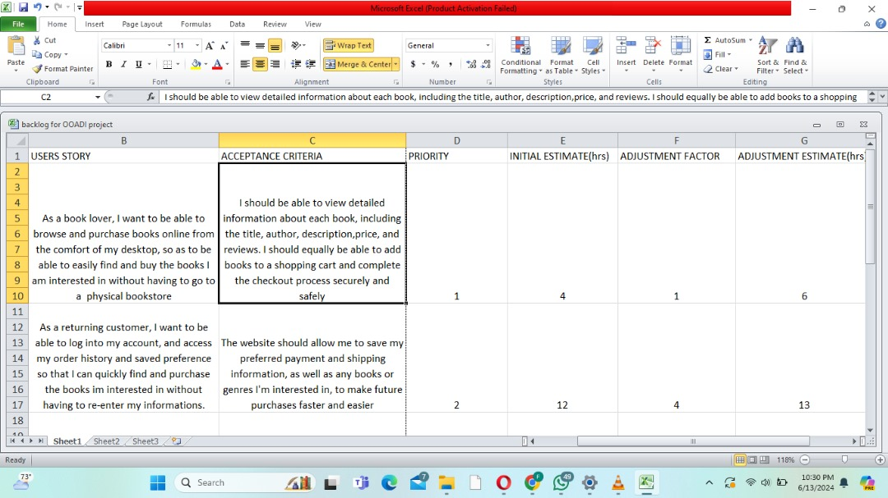

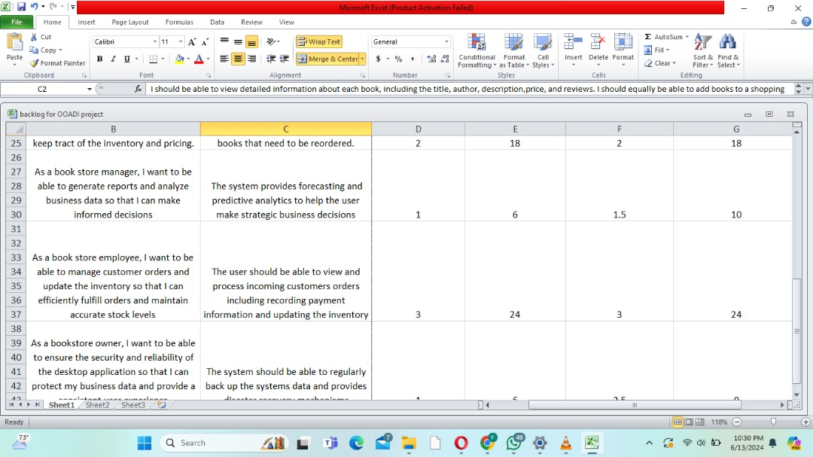

- **Sprint Backlog**: Detailing the specific work items (user stories, tasks, and bugs) that the development team committed to delivering during each sprint

**Test Case Document**

A comprehensive test case document was developed, covering unit tests, integration tests, and end-to-end tests for the online bookstore system. This included test cases for verifying the functional requirements, as well as non-functional aspects such as performance, security, and usability.

**Proposed Algorithms**

Key algorithms developed for this project include:

- Recommendation engine to suggest related books based on customer browsing and purchase history, using collaborative filtering and content-based techniques

- Dynamic pricing model to automatically adjust book prices based on factors such as demand, competitor pricing, and inventory levels

**Materials and Technologies**

The online bookstore system was built using the following technologies:

- Backend: Python, Flask web framework, PostgreSQL database.

- IDE: Visual Studio Code, PyCharm.

- Monitoring and Logging: Prometheus for metrics, Grafana for dashboards, ELK stack for log aggregation and analysis

**Chapter 4: Results and Discussions**

**Screenshots of Various Application Scenarios**

1. **Login Page** 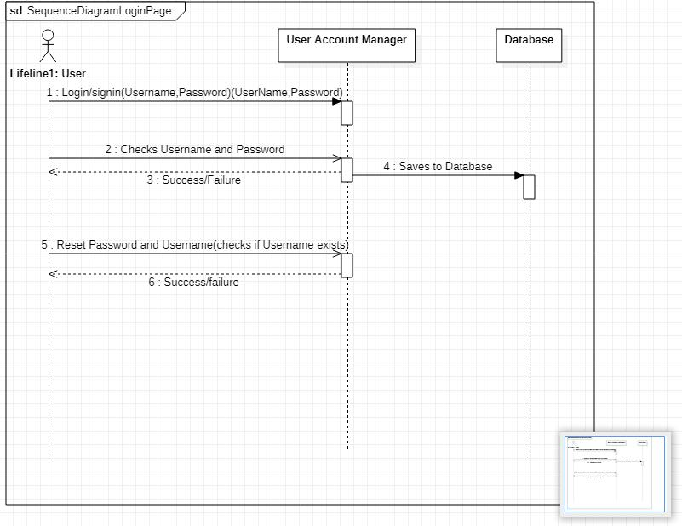

**Book listing page**

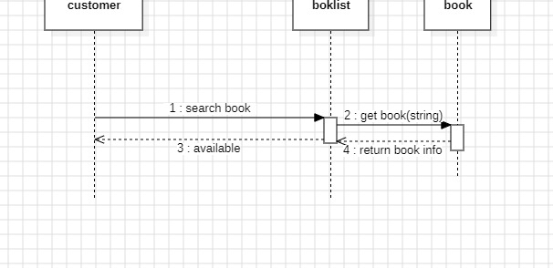

2. **Book Details Page** 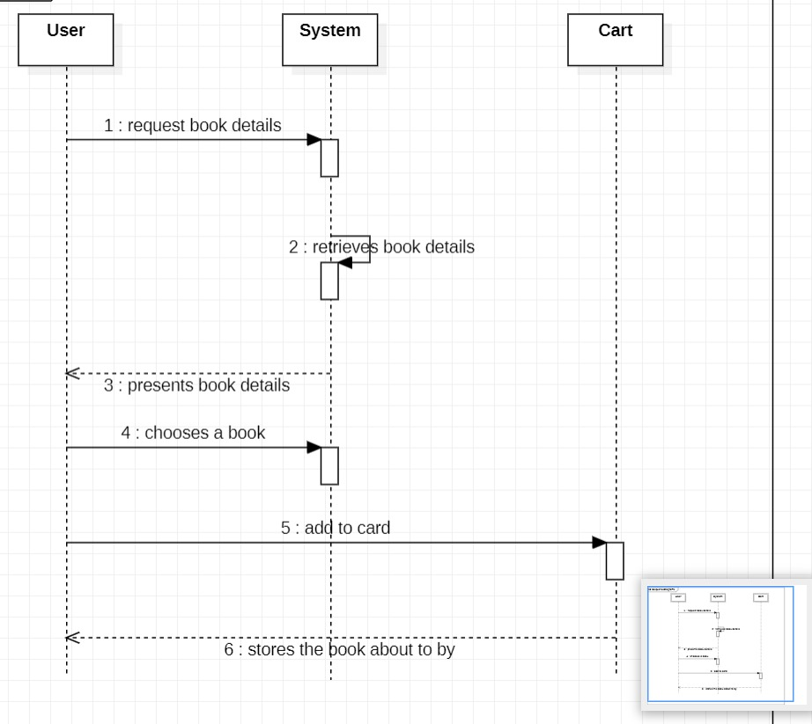

3. **Shopping Cart Page;**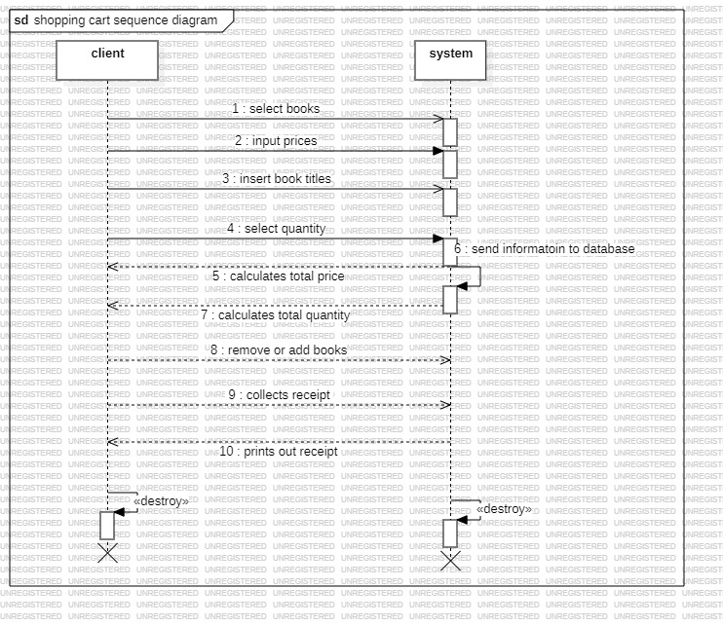

4. **Checkout Page**

- Requires the user to enter their shipping address and select a payment method

- Summarizes the order details, including the items, total price, and shipping information

- Allows the user to review and place the order

**Screenshots of Various API Request/Response:**

**Chapter Four: Recommendations and Conclusion.**

**Summary of Achievements**

Our team has successfully designed and developed a comprehensive online bookstore application that delivers a seamless shopping experience for customers. We have implemented a wide range of features, including a user-friendly interface for browsing and searching the product catalog, a robust shopping cart system, and a secure checkout process. Additionally, we have created a set of APIs that enable efficient management of the bookstore's operations, such as inventory tracking, order fulfillment, and customer account management. These APIs allow for seamless integration with various internal and external systems, ensuring the scalability and flexibility of the overall platform.

**Difficulties Encountered**

During the development process, our team faced several challenges that required careful planning and execution. One of the primary difficulties was integrating the various microservices that make up the bookstore application and ensuring smooth data transfer between them. Ensuring the scalability and reliability of the system as the customer base and product catalog grow was also a significant concern. Additionally, we had to address security considerations, such as protecting customer data and preventing unauthorized access to the application, to maintain the trust and confidence of our users.

**Recommendations for Further Studies**

To further enhance the capabilities and functionality of the online bookstore application, we have identified several areas for future research and development:

1**. Implementing Advanced Recommendation Systems**

Exploring the use of machine learning algorithms and data analysis techniques to provide personalized book recommendations based on customer preferences, browsing history, and purchase patterns. This would help increase customer engagement and drive sales by suggesting relevant products that the customer is more likely to be interested in.

2**. Integrating Mobile Applications:**

Developing mobile-friendly versions of the bookstore application, either through responsive web design or dedicated mobile apps, to cater to the growing number of customers who prefer to shop on the go. This would improve the overall user experience and accessibility of the platform.

3. **Exploring e-Book Integration**

: Investigating the feasibility of integrating e-book offerings into the bookstore's product catalog, providing customers with a wider range of digital content and potentially expanding the business into the rapidly growing e-book market.

4. **Enhancing the Order Fulfillment Process**

Exploring ways to optimize the order fulfillment process, such as integrating with shipping providers to offer real-time tracking and delivery updates, and implementing automation and optimization techniques to improve the efficiency and accuracy of the order processing workflow.

5. **Improving the Analytics and Reporting Capabilities**

Developing advanced analytics and reporting tools to help the bookstore management team make data-driven decisions and optimize business operations. This could include features such as sales forecasting, inventory management, customer segmentation, and marketing campaign analysis.

By addressing these recommendations, the online bookstore application can continue to evolve and provide an even more exceptional user experience, while also improving the overall efficiency, profitability, and competitiveness of the business.